DPU Update Script Design doc 1.2
Contents
1. Description 1
This design document corresponds to version 25.04-2.5.x of the script. 1
2. Design 2
2.1. Architect 2
2.2. Command parameters 2
2.3. Normal output 3
2.4. Error List 3
2.5. Log and Debug 5
2.6. Debugging BFB installation on DPU 5
2.7. Limitations 6
3. Workflow 7
3.1. BMC firmware update 7
3.2. CEC Firmware update 7
3.3. ATF/UEFI firmware update 8
3.4. BUNDLE firmware update 9
3.5. Live Firmware Patch (LFWP) 12
Exhibit A – BFB structure 12
Exhibit B – BFB installation environment 13

Description
DPU update script (OobUpdate.sh) is a program for updating various component firmware of Bluefield DPU, like BMC, CEC and BIOS(ATF&UEFI). It works from out of band, using Redfish API exposed by BMC of DPU. The script can work from any controller host (Linux), which has available connection to the DPU BMC system.

This design document corresponds to version 25.04-2.5.x of the script.

Design

Architect
The DPU Update Script works as following chart:

ARM OS
BMC
ATF/UEFI
DPU
Redfish(Restful) API
DPU Update
Script
Controller Host

- DPU Update Script can run from any machine (Controller Host), which can establish connection to DPU BMC’s OOB interface.
- The script connects and manages the DPU through Redfish (Restful) API exposed by DPU BMC.
- The script is mainly implemented by Python3.

Command parameters

OobUpdate.py [-h] [-U <username>] [-P <password>] [-S <ssh_username>] [-K <ssh_password>]
[-F <firmware_file>] [-T <module>] [--with-config] [-H <bmc_ip>]
[-C] [-o <output_log_file>] [-p <bmc_port>]
[--bios_update_protocol <bios_update_protocol>] [--config <config_file>]
[--bfcfg <bfcfg>] [-s <oem_fru>] [-v] [--skip_same_version]
[--show_all_versions] [-d] [-L <path>] [--task-id <task_id>] [--lfwp]

options:
-h, --help Show this help message and exit
-U <username> Username of BMC
-P <password> Password of BMC
-S <ssh_username> Username of BMC SSH access
-K <ssh_password> SSH password of BMC
-F <firmware_file> Firmware file path (absolute/relative)
-T <module> The module to be updated: BMC|CEC|BIOS|FRU|CONFIG|BUNDLE
--with-config Update the configuration image file during the BUNDLE update process.
Do not use –lfwp together with this option.
-H <bmc_ip> IP/Host of BMC
-C Reset to factory configuration (Only used for BMC|BIOS)
-o <output_log_file>, --output <output_log_file>
Output log file
-p <bmc_port>, --port <bmc_port>
Port of BMC (443 by default).
--bios_update_protocol <bios_update_protocol>
BIOS update protocol: HTTP or SCP
--config <config_file> Configuration file
--bfcfg <bfcfg> bf.cfg - BFB configuration file
-s <oem_fru> FRU data in the format "Section:Key=Value"
-v, --version Show the version of this scripts
--skip_same_version Do not upgrade, if upgrade version is the same as current running version.
Relevant to BIOS|BMC|CEC modules only.
--show_all_versions Show firmware versions of all modules
-d, --debug Show more debug info
-L <path> Linux path to save the cfg file
--task-id <task_id> Unique identifier for the task
--lfwp Live Firmware Update patch. Works only with BUNDLE module.
Do not use –with-config together with this option.

Normal output
In normal successful case, the script will only have a few messages show in standard output. Like following:
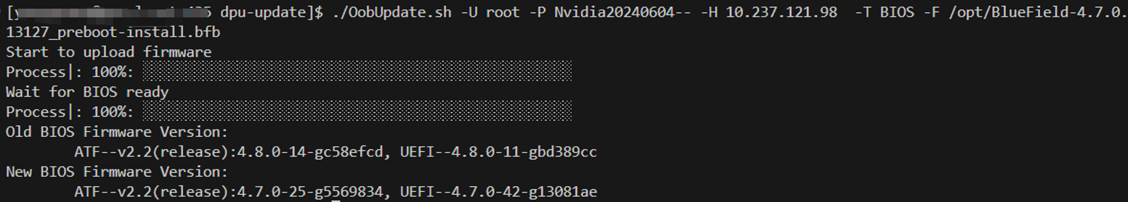

Error List
While this script is running, errors may be encountered. Related error message will show in error output.

Following is error list the script may encounter:
Index | Error Name | Error Message
1 | ARG_FOR_UPDATE_NOT_GIVEN | BMC IP/Username/Password, Firmware file path and Module are needed to do firmware update
2 | ARG_FOR_VERSION_NOT_GIVEN | BMC IP/Username/Password are needed to show versions of all firmwares
3 | FILE_NOT_ACCESSIBLE | File is not accessible
4 | FW_FILE_NOT_MATCH_MODULE | Given firmware file is NOT for the Module to update
5 | BMC_CONNECTION_FAIL | Failed to establish connection to BMC. Please check the BMC IP and port
6 | BMC_CONNECTION_RESET | Connection to BMC being reset by remove
7 | BMC_CONNECTION_OTHER_ERR | Connection failed
8 | ACCOUNT_LOCKED | Account has been locked
9 | INVALID_USERNAME_OR_PASSWORD | Invalid username or password
10 | ANOTHER_UPDATE_IS_IN_PROGRESS | Another update is in progress; Please try to update the firmware later
11 | UNSUPPORTED_MODULE | Unsupported updating module
12 | BAD_RESPONSE_FORMAT | Bad response format
13 | EMPTY_FW_VER | Empty firmware version in response
14 | INVALID_STATUS_CODE | Invalid response status code
15 | FAILED_TO_GET_LOCAL_KEY | Failed to get local SSH Key
16 | FAILED_TO_ENABLE_BMC_RSHIM | Failed to enable BMC rshim; Please make sure rshim on Host side is disabled
17 | NOT_SUPPORT_CEC_RESTART | CEC restart redfish API is not supported in this version; Please use power cycle of the whole system instead
18 | BMC_BACKGROUND_BUSY | BMC is busy on background operation; Please try to update the firmware later
19 | PUBLIC_KEY_NOT_EXCHANGED | Public key was not exchanged with BMC successfully
20 | TASK_FAILED | Task failed
21 | NEW_VERION_CHECK_FAILED | New running version check failed
22 | FAILED_TO_GET_VER_FROM_FILE | Failed to get firmware version from file
23 | FAILED_TO_START_HTTP_SERVER | Failed to start HTTP server
24 | NOT_SUPPORT_SIMPLE_UPDATE_PROTOCOL | NO supported BFB update protocol
25 | BIOS_FACTORY_RESET_FAIL | Failed to do BIOS factory reset
26 | TASK_TIMEOUT | Task timeout
27 | PUSH_URI_NOT_FOUND | Push URI not found
28 | HTTP_FILE_SERVER_NOT_ACCESSIBLE | HTTP file server is not accessible from BMC
29 | INVALID_BMC_ADDRESS | Invalid BMC Address
30 | CURL_COMMAND_FAILED | Curl command failed
31 | INVALID_INPUT_PARAMETER | The input parameter provided is invalid
32 | USERNAME_NOT_GIVEN | BMC user name is not given
33 | PASSWORD_NOT_GIVEN | BMC password is not given
34 | BMC_IP_NOT_GIVEN | BMC IP is not given
35 | MODULE_NOT_GIVEN | Module to update is not given
36 | FW_FILE_NOT_GIVEN | Firmware file is not given
37 | FRU_NOT_GIVEN | FRU is not given
38 | UPDATE_SERVICE_NOT_READY | Update service is not ready(enabled)
39 | NO_PENDING_CEC_FW | CEC firmware was not updated
40 | BMC_GOLDEN_IMAGE_CONFIG_DIR_ERR | NO /tmp/golden-image-config DIR on BMC
127 | OTHER_EXCEPTION | Other Errors

Log and Debug
There are some additional logs recording details of each restful request & response. Those logs can be used in debugging issues.
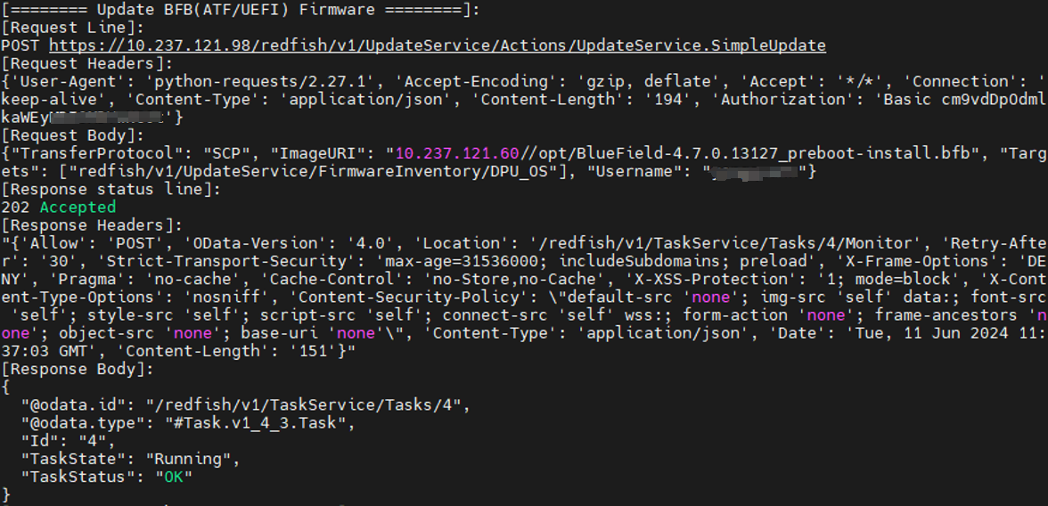
- If command has argument -d (--debug) , those additional logs will be shown in output
- If command has argument -o (--output_log_file), those additional logs will be written into the log file.

Debugging BFB installation on DPU
To get more information on the DPU console log use external bf.cfg file with the following lines:
bf.cfg:

set -x
exec 1>/dev/hvc0 2>&1

Run OobUpdate:
# ./OobUpdate.sh -H <BMC IP> \
-U <Redfish User> -P <Redfish user’s password> \
-S <SSH user> -K <SSH user’s password> \
-T BUNDLE -F <BFB> \
--output /tmp/dpu-update.log \
--bfcfg /root/bf.cfg

Login into BMC using the SSH user:
$ ssh -l <SSH user> <BMC IP>
dpu-bmc:~$ obmc-console-client
See the BFB installer and DPU OS boot messages and login prompt.
See bf.cfg Parameters description in the Nvidia BlueField BSP user manual: https://docs.nvidia.com/networking/display/bluefieldbsp4120/customizing+bluefield+software+deployment#src-4161918912_CustomizingBlueFieldSoftwareDeployment-bf.cfgParameters

Limitations
- The script can only run on Linux host, with python3 installed
- The rshim on Host side (in which DPU plugged) need to be disabled, if want to update BIOS firmware of DPU or use BUNDLE module
- The target DPU BMC version should be >= 24.04
  - Some redfish API may not be supported for earlier BMC versions.
  - That also means the script can only support >= Bluefield 3
  - The DPU BMC needs to be upgraded to >= 24.04 by other means, before using this script.
- The target DPU BMC version should be >= 25.04
  - To support Live Firmware Patch (LFWP)
- The default user/password of DPU BMC should be updated in advance.
- For one DPU system, there can only be one update task at the one time. The later coming task will get “Another update is in progress" error.
- In NIC mode, the BMC's Redfish chassis schema contains only limited information about BlueField (like versions of different components). This is because, in this mode, the OS is not available to supply the necessary information to the BMC.

Workflow

BMC firmware update
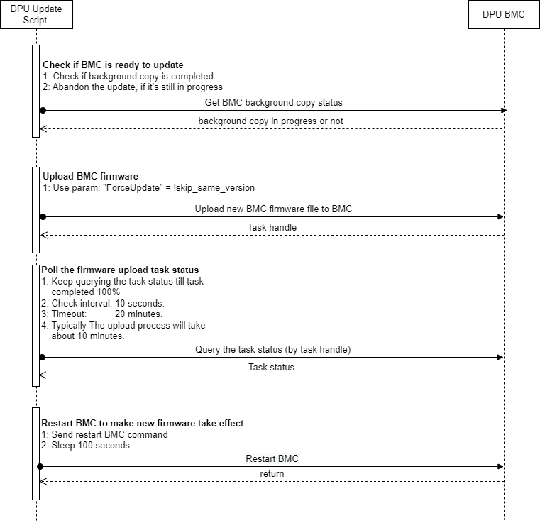

CEC Firmware update
The CEC firmware update workflow is similar as BMC firmware update. Except for following:
- The upload process will take less than 4 minutes
- Will check task status every 2 seconds
- Will wait 120 seconds, after CEC restart.

ATF/UEFI firmware update
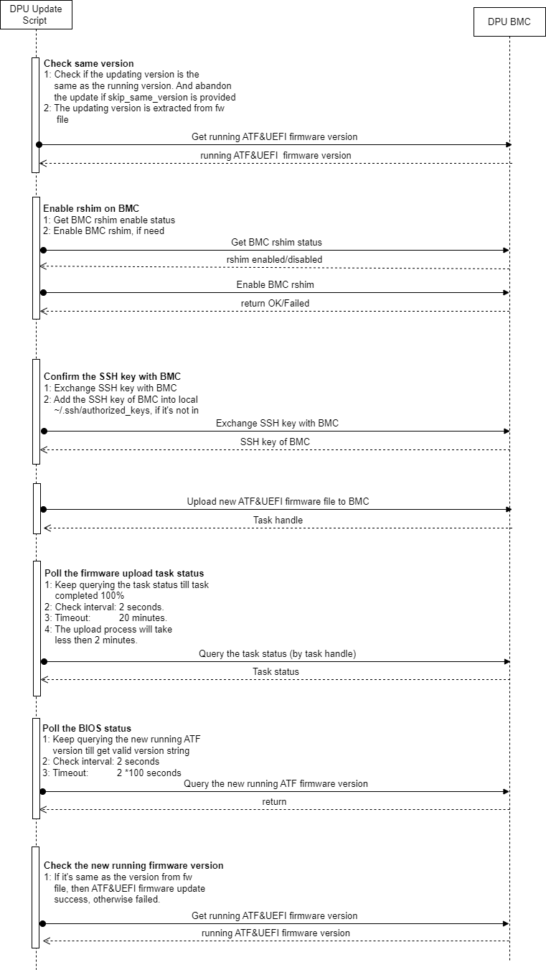

BUNDLE firmware update
The bf-fwbundle BFB update process uses the Redfish SimpleUpdate API to transfer firmware bundles to the BMC. Key stages:
- OobUpdate validates arguments and confirms BMC SSH credentials are provided.
- Creates bf.cfg configuration file (/tmp/task_<task_id>_<random string>/<task_id>_<random string>.cfg) and appends to the original bf-fwbundle BFB:
BMC_USER=<Redfish_username>
BMC_PASSWORD=<Redfish_password>
BMC_SSH_USER=<SSH_username>
BMC_SSH_PASSWORD=<SSH_password>
BMC_REBOOT="yes"
CEC_REBOOT="yes"
2.1. If the bf.cfg is provided using ‘--bfcfg <bf.cfg>’ parameter, it will be appended to the configuration file mentioned above.

- Checks for config-image.bfb presence in the bf-fwbundle to determine if ResetBios is required post-update.
Note: config-image.bfb will not be updated by default.
To enable config-image.bfb update use ‘--with-config’ parameter.
- Parses the info.json file included with the bf-fwbundle to extract the component versions from the bundle. This information is printed at the end of the process, allowing a comparison between the original component versions installed on the DPU and the new versions running on the DPU after the update.
- BFB update sequence:
  - Enable RSHIM on the BMC via Redfish API
  - Initiates SimpleUpdate task to transfer BFB via RSHIM
    - Simple Update sends the bf-fwbundle BFB to the DPU via RSHIM interface and finishes once the BFB is fully uploaded. During this time the DPU resets and starts running the BFB installation environment.
    - BFB installation environment is running on the DPU. Update sequence:
      - ATF/UEFI firmware capsule
      - Create a VLAN interface on the DPU to connect to the DPU's BMC, enabling Redfish and SSH commands to be run on the BMC.
      - BMC Firmware (if not the same) – Redfish API
      - BMC restart to apply the new version (disconnects BMC console)
      - CEC Firmware (if not the same)
      - CEC restart to apply the new version
      - DPU Golden Image
      - NIC Firmware Golden Image (if exists)
      - config-image.bfb (if the ‘--with-config’ was provided)
      - NIC Firmware
      - NIC Firmware reset using mlxfwreset to apply the new version (if supported in current state)
      - Reset DPU to finish the installation
      - New ATF/UEFI activated
      - Load DPU OS
- Waits for the DPU readiness
- DPU reset to apply the new configuration from the config-image.bfb (if the ‘--with-config’ was provided).
- Additional DPU reset to update the BMC with the new configuration from the config-image.bfb (if the ‘--with-config’ was provided).
- Waits for the DPU readiness

- Collects new versions of all the running components
- Generates version comparison table

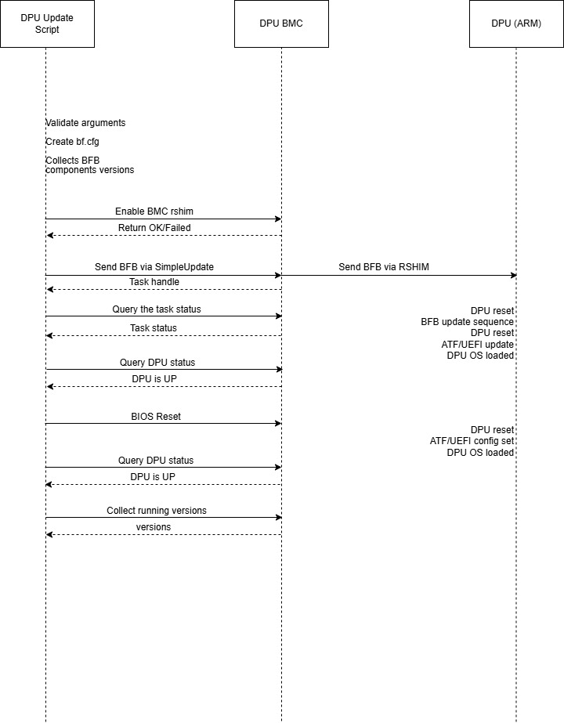

Live Firmware Patch (LFWP)
If a DPU NIC firmware update supporting LFWP is available, it can be applied by adding the --lfwp option to the standard set of parameters when running the bf-fwbundle. A BFB with LFWP support is expected to contain the same components as the original bf-fwbundle, except that the NIC firmware to be updated is replaced. If any other components differ, they will also be updated, but new versions will not become active until the next power cycle or system reset.
Note: An LFWP update can only be successfully activated if it is applied to NIC firmware with the same major version for which the LFWP was created.

Exhibit A – BFB structure

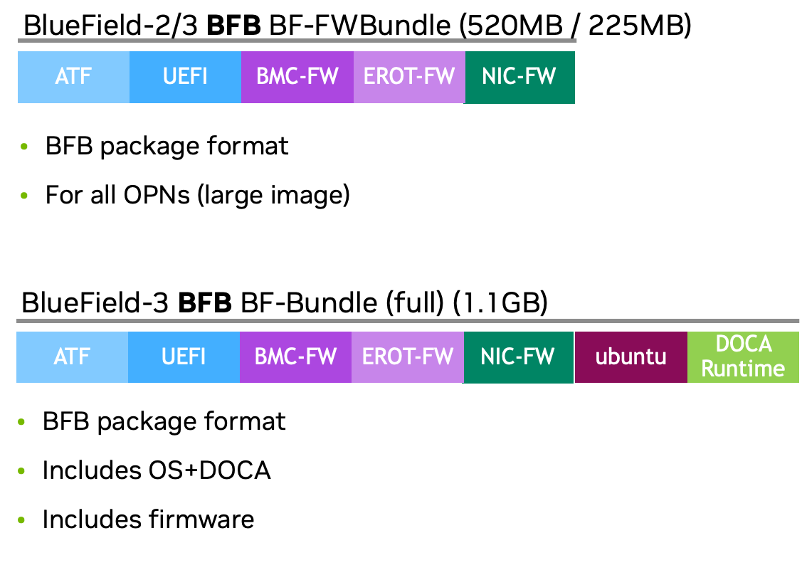

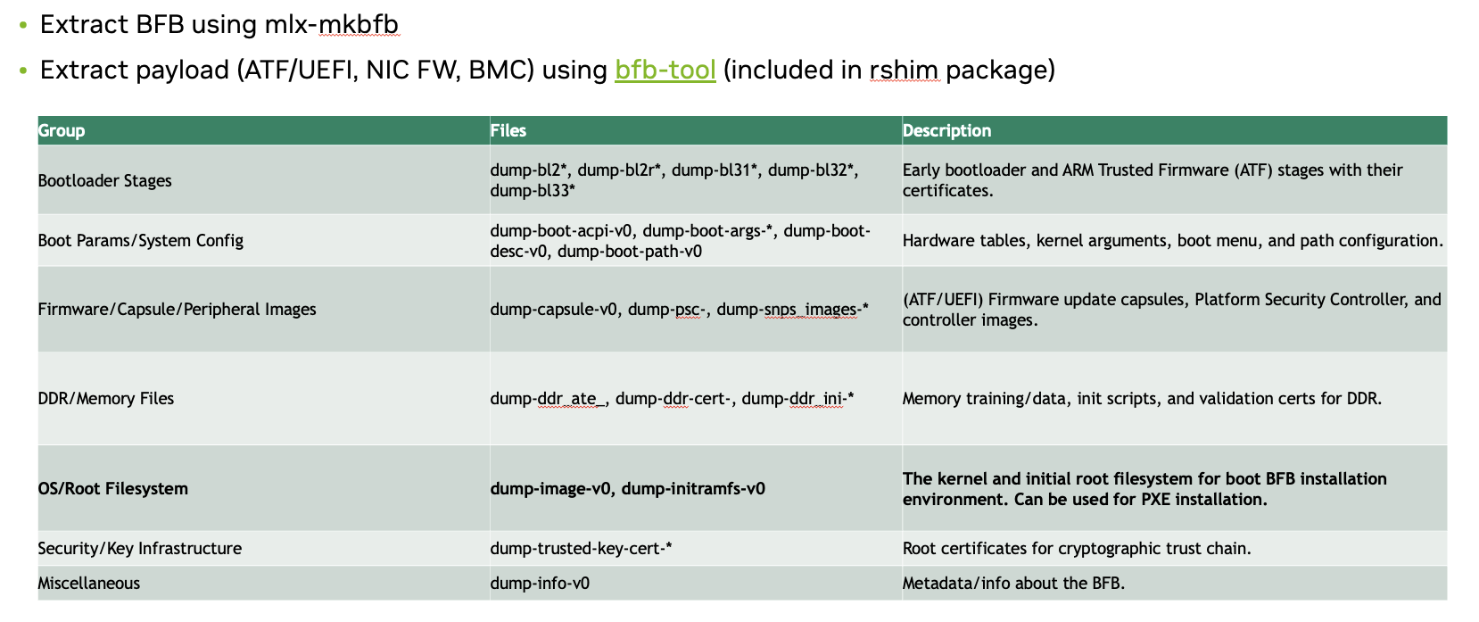

To extract the BFB content run:
$ mlx-mkbfb -x <BFB>

Exhibit B – BFB installation environment
BFB installation environment is available under https://github.com/Mellanox/bfb-build/tree/lts-2.9.x

bf-fwbundle installation script: https://github.com/Mellanox/bfb-build/blob/lts-2.9.x/ubuntu/22.04/install.sh
BFB installation environment used by the BFB installation script:
https://github.com/Mellanox/bfb-build/tree/lts-2.9.x/common/install.env

